1. Simplify the following:
$$\frac{3 \frac{1}{2}}{\frac{3}{4}}$$

The following table shows different sizes of cans of peanuts and their cost.
Cans of Peanuts
Size (oz) | Cost ($)
5 | 2.25
10 | 3.50
20 | 10.00
Which can size has the lowest unit cost? __________________

3. I can bake $\frac{3}{4}$ of a cake in 5 minutes. How much of the cake can I bake in 1 minute?

4. What 2 things MUST be true for a graph to be proportional?

5. Are the following ratios proportional? $\frac{150}{300}$ and $\frac{450}{600}$

6. If you can bake 26 cookies in 8 minutes, how many cookies can you bake in 32 minutes?

7. Does the following table show direct variation? ___________ Find k ____________

X | 4 | 6 | 7 | 9
y | 12.8 | 19.2 | 22.4 | 28.8

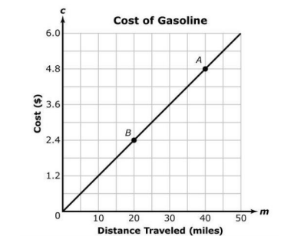
8.
The following graph shows the relationship between the cost of
gas and distance traveled.
Find k: ________________

9. The actual distance between LA and San Francisco is 150 miles. The scale for the map is 1 cm = 40 miles. How far apart are the two cities on the map?

10. You can read $\frac{1}{3}$ of a book in $\frac{3}{5}$ of an hour. How much can you read in 1 hour?

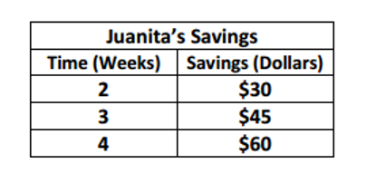
11. Find the constant of proportionality in the table.
Then find the equation in the y = kx form.

