Scale Drawings Activity
Problem: How do you draw a human heart to scale and use ratios to create a paint that best models human heart?
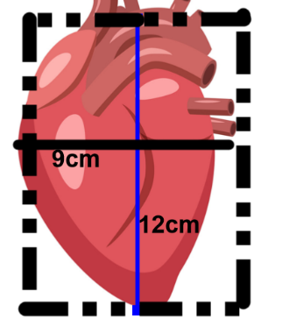
Part one create a large scale model of the human heart:
The actual human heart is 12cm long and 9cm wide
What is the estimated area of the actual cross sectional (2d) area
Of the human heart? A =______square cm A=base X height
The next step is we want to create a scale drawing on a
Rectangular piece of paper that is 30cm long and 22cm wide.
- Determine the scale that will best fit the enlarged scale drawing:
Scale: ________cm to 1cm (hint: Think of the how many times the actual length can go into the length of the paper without going over the number. You want your scale to be a whole number)

Length of heart Actual: 12cm Length of scale drawing:_________cm

With of heart Actual: 9cm Width of scale drawing:__________cm

Area of the model cross sectional (2d) area of the human heart: A=_______square cm
Sketch your drawing the piece of construction paper and make sure to include the scale in the bottom left hand corner and show the dimensions of your model heart and include the Area.
Analysis:
- Can you use the area of the actual heart and the scale to find the area of the drawing?
(take the area of the heart and multiply it by your scale factor and see if the area of the scale drawing is the same as above)

Explain why or why not:________________________________________________________________________________________________________________________________________________________________________________________________________________________________________________________.
Explain why scientists would take cross sections of the body systems and enlarge them as scale drawing: (3-4 sentences).
_________________________________________________________________________________________________________________________________________________________________________________________________________________________________________________________________________________________________________________________________________________________________________________________________________________________________________.

Part 2.
At the bodies exhibit they used a process to preserve the body but the color was not maintained, so a natural pigment was needed that would best model the color of the different portions of the body. In this case we are looking for the pigment that best models the heart.

