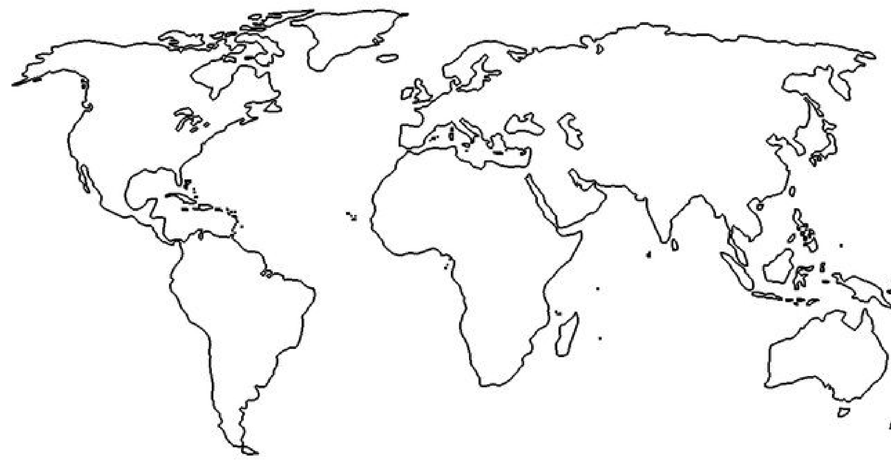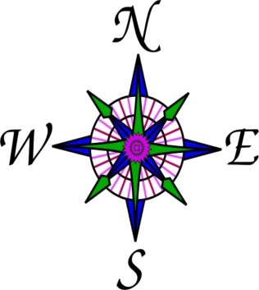

Name_____________________________ Date: ________ Period____

Student

New
S

Analy
S
i
S

Africa

Asia

Europe

Australia

South

America

North

America

Directions: Fill in the graphic organizer on the news story
’
.

- Map: Place a star  on the map approximately where the breaking news story is taking place.
- Summarize: Summarize the news story in 4-5 sentences. ____________________________________________________________________________________________________________________________________________________________________________________________________________________________________________________________________________________________________________________________________________________________________________________________________________________________________________________________________________________________________________________________________________________________________________________________________________________________________________________________________________________________________________________________________________________________________________________________________________________________________________________________________________________________________________________________________________________________________________________________________________________________________________________________________________________________________
- Make a Connection: How does this news story connect with something you have already learned about this part of the world? Be specific.
____________________________________________________________________________________________________________
____________________________________________________________________________________________________________
____________________________________________________________________________________________________________
____________________________________________________________________________________________________________

Copyright © 2016 Instructomania

Copyright © 2016 Instructomania
Name____________________________________________ Date: ______________ Period: _______
Use the text to constructively read and extract important information. Make sure the main idea, section summary and conclusion sections reflect thoughtful analysis with complete sentences.

IDENTIFY THE TOPIC
News topic: ________________________________________________________________________________
MAIN IDEA Describe the main, or central idea of one of the news stories viewed.
______________________________________________________________________________________________
______________________________________________________________________________________________
CITE SUPPORTING EVIDENCE Choose 2 sentences that support the main idea of the news story. Try your best to use direct quotes.
“_______________________________________
________________________________________
________________________________________
________________________________________
_______________________________________” “_______________________________________
________________________________________ ________________________________________
Draw a map, chart or graphic from the section here. _______________________________________”
STORY SUMMARY Write 2-3 sentences that summarize the news story (who, what, when, where, how).
_____________________________________________________________________________________________
_____________________________________________________________________________________________
_____________________________________________________________________________________________
_____________________________________________________________________________________________
_____________________________________________________________________________________________

CONCLUSION Write a brief conclusion that can be drawn from the news story. Remember, conclusions often reflect the main idea.
_____________________________________________________________________________________________
_____________________________________________________________________________________________
_____________________________________________________________________________________________
Common Core Literacy: R1, R2, R4, R7, Copyright © 2016 Instructomania

