McCleskey Middle School
Math 7
2018-2019
Mrs. Sangster kelly.sangster@cobbk12.org
Mrs. Henry jeri.henry@cobbk12.org

Pacing Guide:
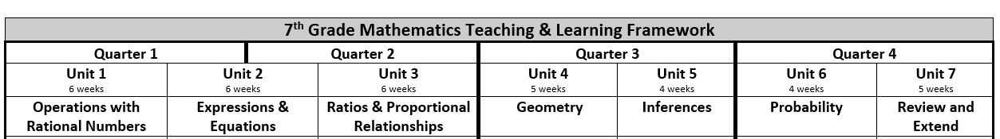

*These times are approximate, and may change to accommodate classes which may need less or additional time. ***This syllabus is subject to change.****

Textbook Information:
McGraw Hill Georgia Math Grade 7 volume 1 – *the replacement cost is $10.00
McGraw Hill Georgia Math Grade 7 volume 2 – *the replacement cost is $10.00

Students will have a consumable textbook. Only one volume will be passed out at the beginning of the year. Students will be expected to bring the textbook everyday to class. Online access will be provided to students by the 2nd week of school.

Grading Procedures:
Summative Assessment: 70% This includes: Tests- 40% Quizzes- 30%

Formative Assessment: 30% This includes: Practice (homework & classwork) 30%

Materials:
Binder, spiral notebook, 7th grade homework folder, pencil pouch with basic school supplies: pencils, eraser caps, dry erase markers, 4 function calculator)

Tutoring:
Stay tuned for upcoming tutoring information!

Fun Facts about 7th Grade Math:
*When checking grades please refer to the comments (if any). This may answer some questions you have about the assignment.

*When I refer to a tiered activity I am talking about an assignment where students are working on the same skill/concept, but at varying levels. The tier a student is assigned is based on, but not limited to: a pre-test, an opening (warm-up), a quiz, or an exit ticket

*I do not give extra credit. Students may have the opportunity to earn bonus points on quizzes and tests.

HOMEWORK:
Homework is expected to be completed the same night it is assigned, and it will not be accepted late. Homework is SO important in math class!

Parent Tips:
Parents should register to receive access to Synergy ParentVue(the free online grade book), which can be used to keep up with student progress. Information is available using a computer or App installed on a SmartPhone or tablet.
While at home, parents are encouraged to:
- Set a regular time and routine for doing homework.
- Establish a regular place that is well lit and quiet for completing homework.
- Remove distractions during home study time. No television, fortnite, phone calls, or texting.
- Insist that homework assignments are completed daily.

Please Note:
I have observed that students, who turn in their work on the required dates, complete/study their unit review sheet, and who study for their tests and quizzes typically perform better on the unit tests.

Ways to Stay Informed:
*PLEASE CHECK THE BLOG DAILY!!! http://cervinomath7.weebly.com/

*Remind- If you would like to receive text messages to be reminded of upcoming and important dates
Text: 81010 Message: sangsterm

*Twitter- follow me on twitter to keep up with fun things going on in the classroom & reminders! @MrsKSangster

*Instagram- follow me on twitter to keep up with fun things going on in the classroom & reminders! @kcsangster

We are looking forward to a great year in 7th grade math!

