The Great Cartoon Blow UP

In this activity we will start with a small cartoon, and we will "blow it up."

We will choose a scale to create the enlargement. This is called a *dilation*.

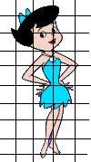

1. We will create the grid on our   
cartoon picture. It will be 1cm by 1cm

2. We will pick a scale to dilate our cartoon. (Choose from a scale of x5, x6, or x7) Your picture needs to cover as much of the poster board as possible.

3. We will create the scale on our poster board. (Example: If you chose a scale factor of 5, your new grid on the poster board would be 5cm by 5cm) A meter stick must be used, and the lines must be straight.

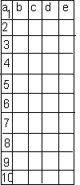

4. You will then label the grids with letters across the columns at the top,  
 and numbers down the rows.

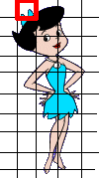

5. After this has been approved by Ms. Sangster, Mrs. Henry, or Mr. Wright you will begin drawing. Remember you are not being graded by your artistic ability, but rather being able to produce the enlarged **proportional** drawing. Take each individual cell or square and draw exactly what you see in the corresponding cell.

After you finish your project respond to the following questions & glue to the back of your poster.

1) This year we have learned about dilations, both getting larger and smaller. Explain what scale factor gives you a smaller object and what scale factor gives you a larger object.   
**(3 sentences)**

2) Name 2 activities we have done already this year: one dilation with shrinking and one dilation where the object got larger. **(2 sentences)**

3) Are your 2 pictures (your original picture & your poster creation) proportional? How can you tell? **(3 sentences)**

4) An engineer makes a model of a bridge using a scale of 0.5 cm = 3 feet. The length of the actual bridge is 123 feet. What is the length of the model?

5) A map of Smithfield has a scale of 1 inch = 5 miles. If the city is 4 $\frac{1}{5}$ inches across on the map, what is the actual distance across the city?